Application to perform CRUD operations in Mongo DB using Javascript

EX NO: 6 NAME : R.B. Dwaraka Dharshini
DATE: ROLL NO:25MCA003

Aim:
To implement a robust and type-safe backend script using JavaScript and the MongoDB Node.js Driver to perform the four fundamental CRUD operations on a local MongoDB database.

Procedure:

- Launch MongoDB Server: Ensure your local MongoDB service is active. On Windows, you can verify this by checking that the "MongoDB Server" is "Running" in your system Services.
- Initialize Project: Open your terminal in your project folder (D:\full stack ex\mongodb) and run npm init -y. This creates the package.json file needed to manage your project.
- Install MongoDB Driver: Run npm install mongodb in your terminal. This downloads the official Node.js library required for your script to communicate with the database.
- Create Script File: Create a new file named server.js (or index.js) and paste your JavaScript code into it.
- Connect to Database: The script uses MongoClient to establish a connection to your local server at 127.0.0.1:27017.
- Access Database and Collection: The code specifically targets the database named "mca" and the collection named "test".
- Execute Insert Operation: When you run the script, it inserts 5 new records (Dwaraka, Ravi, Tanishka, Priya, and Geethu) into the collection.
- Execute Update Operation: The script searches for the record where the name is "priya" and changes her age to 20.
- Fetch Updated Data: The script performs a second findOne for "priya" and logs it to the terminal so you can immediately see that the age change was successful.
- Execute Delete Operation: The script attempts to delete a record with the name "geehu". (Note: This will result in 0 deletions unless the typo is fixed to "geethu").
- Run and Verify: Open your terminal and type node server.js. After the "Connection closed" message appears, open MongoDB Compass, refresh the "mca" database, and click on the "test" collection to view the final stored data.

server.js :

const { MongoClient } = require("mongodb");
const uri = "mongodb://127.0.0.1:27017";
const client = new MongoClient(uri);
async function run() {
try {
// Connect to MongoDB
await client.connect();
console.log("Connected successfully to MongoDB");
const database = client.db("mca");
const collection = database.collection("test");
// INSERT MANY (CREATE)
const users = [
{ name: "Dwaraka", age: 21, role: "Admin" },
{ name: "Ravi", age: 47, role: "User" },
{ name: "Tanishka", age: 15, role: "User" },
{ name: "priya", age: 19, role: "User" },
{ name: "geethu", age: 25, role: "User" }
];
const insertResult = await collection.insertMany(users);
console.log(`${insertResult.insertedCount} documents inserted`);
console.log("Inserted IDs:", insertResult.insertedIds);
// FIND ONE (READ)
const user = await collection.findOne({ name: "Dwaraka" });
console.log("Found user:", user);
// UPDATE ONE (UPDATE)
const updateResult = await collection.updateOne(
{ name: "priya" }, // Filter
{ $set: { age: 20 } } // Update
);
console.log(`${updateResult.matchedCount} document matched`);
console.log(`${updateResult.modifiedCount} document updated`);
// FETCH AND DISPLAY UPDATED RECORD
const update = await collection.findOne({ name: "priya" });
console.log("Updated record:", update);
// DELETE ONE (DELETE)
const deleteResult = await collection.deleteOne({ name: "geehu" });
console.log(`${deleteResult.deletedCount} document deleted`);
} catch (err) {
console.error("Error:", err);
} finally {
// Close connection
await client.close();
console.log("Connection closed");
}}
run();

OUTPUT:

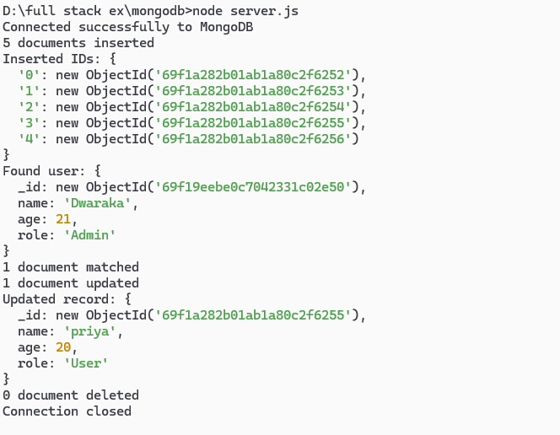
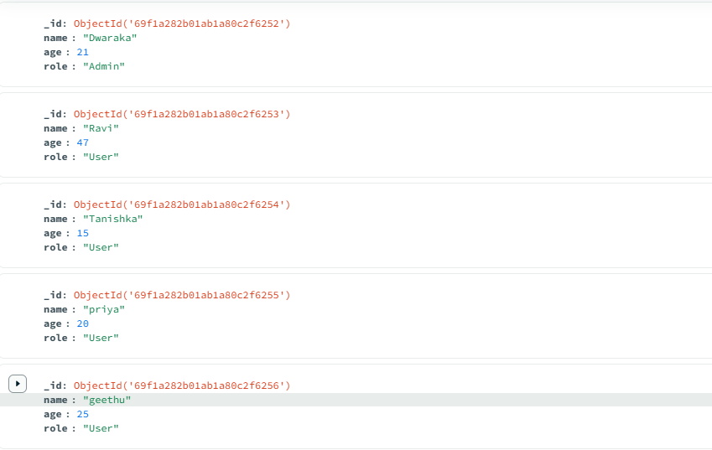

RESULT:
Thus, the JavaScript code successfully executes CRUD operations by communicating with the MongoDB server to modify and retrieve data. The output confirms that the database state has been updated according to the specific commands issued.

